ITA0305- Mobile Computing
LAB EXPERIMENT
Name: G.Ganesh
Reg NO:192373008

5) Design a wireframe for a mobile application that incorporates localization features
using Figma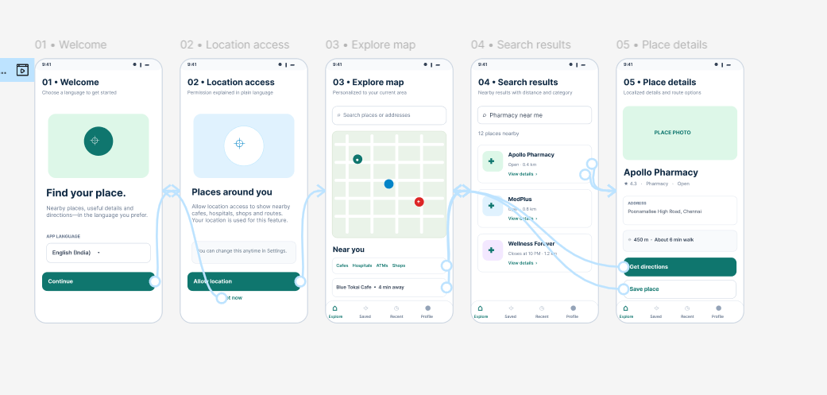
https://www.figma.com/design/D9TvZzr4T4H7NgtpZk8dWQ/program05?node-id=1-2&p=f&t=VR9HhR53zoANYz1M-0

